STATE OF HAWAIʻI
INVITATION FOR BIDS (IFB)
FOR INSTALLATION OF 6-FOOT CHAIN-LINK FENCING

Sealed bids will be received by the State of Hawaiʻi, Department of Land and Natural Resources, Division of Forestry and Wildlife via HIePRO (Hawaiʻi eProcurement System) until May 14, 2026 at 2:00PM HST.

Project Title: DOFAW Hanapepe Office Chainlink Fence
Project Location: Kauai, DOFAW Hanapepe Office, TMK 419005049
HIePRO Solicitation No.: B26002617

2.0 SCOPE OF WORK
The Contractor shall furnish all labor, materials, tools, equipment, transportation, and incidentals necessary to install approximately 225 Linear Feet of 6-foot-high chain-link fencing in accordance with these specifications.

Line item 1: Furnish and deliver ALL material
All fence material shall be delivered to 4398D Pualoke Road, Lihue HI 96766. See specifications below. Should have enough material to construct at least 225 linear feet of 6’ chainlink fence.

Line item 2: Construct chainlink fence (contractor shall furnish all necessary labor, tools, equipment, transportation and incidentals).
Installation of fence shall include:
- Site preparation (minor clearing, grading)
- Layout and staking
- Installation of posts, rails, fabric, and gates (if applicable)
- Concrete footings
- Cleanup and disposal of debris
- Restoration of disturbed areas

3.0 TECHNICAL SPECIFICATIONS
3.1 General
All materials shall be new and free from defects. Installation shall conform to industry standards and applicable ASTM specifications.
3.2 Fence Height and Length
- Finished height: 6 feet above grade
- Finished length: Approximately 225’ combined from two sections of fencing. (length must be verified by contractor on site and shall be plumb to buildings and corners)
3.3 Fence Fabric
- 9-gauge galvanized steel chain-link fabric
- 2-inch diamond mesh
- Coating:
  - Class 2 galvanized OR
  - Vinyl-coated (black or green) over galvanized core (required for coastal/high corrosion zones)
3.4 Posts and Rails
- Line Posts: Minimum 2-3/8" OD galvanized steel pipe, spaced ≤10 ft OC
- Terminal Posts: Minimum 2-7/8" OD galvanized steel pipe
- Top Rail: Continuous 1-5/8" OD galvanized pipe
- Bottom: 7-gauge tension wire OR bottom rail (as specified)
3.5 Footings
- Minimum 10" diameter x 30" depth (adjust for soil conditions)
- Concrete: Minimum 3,000 psi
- Posts plumb and aligned
3.6 Fittings
- Galvanized steel or aluminum fittings
- Ties spaced per ASTM F567
3.7 Gates
- Amount: Two (2)
- Type: 20’ double swing gate
- Frame: Galvanized steel tubing
- Hardware: Hinges, latch, lockable mechanism

4.0 STANDARDS
Work shall comply with:
- ASTM A392 – Zinc-Coated Steel Chain-Link Fabric
- ASTM F567 – Installation of Chain-Link Fence

5.0 PREVAILING WAGE REQUIREMENTS (Chapter 104, HRS)
This project is subject to Chapter 104, Hawaiʻi Revised Statutes (Wages and Hours of Employees on Public Works).
5.1 Wage Rates
- Contractor shall pay all laborers and mechanics not less than the prevailing wage rates as determined by the Hawaiʻi Department of Labor and Industrial Relations (DLIR).
- Applicable wage rate schedule: DLIR Wage Rate Schedule No. [INSERT], including all current updates.
5.2 Certified Payroll
- Contractor and all subcontractors shall submit weekly certified payroll records (Form WH-38 or equivalent).
5.3 Posting Requirements
- Wage rate schedule shall be posted at the job site in a visible location.
5.4 Compliance
Failure to comply may result in:
- Withholding of payments
- Contract termination
- Debarment pursuant to HRS §104

6.0 PERMITS AND UTILITIES
- Contractor shall obtain all necessary permits unless otherwise specified
- Contractor shall verify underground utilities (call 811) prior to excavation

7.0 CONTRACT TIME
- Notice to Proceed issued by the State
- Shall be completed within 365 calendar days from NTP

8.0 INSURANCE REQUIREMENTS
Contractor shall provide:
- General Liability: $1,000,000 per occurrence
- Workers’ Compensation (per HRS Chapter 386)
- Automobile Liability: $1,000,000
State of Hawaiʻi shall be named as additional insured

9.0 BID SUBMITTAL REQUIREMENTS
Bidders shall submit via HIePRO:
- Bid Form (lump sum and/or unit price per linear foot)
- Contractor’s License (Hawaiʻi C-13 Fencing or appropriate classification)
- References for similar projects

10.0 CONTRACTOR QUALIFICATIONS
- Must hold a valid Hawaiʻi contractor’s license at time of bid opening
- Experience with similar fencing projects preferred
- Demonstrated ability to comply with Chapter 104 requirements

11.0 AWARD OF CONTRACT
Award shall be made to the lowest responsive, responsible bidder in accordance with HRS Chapter 103D.

12.0 CONTACT INFORMATION
Procurement Officer:
Mapuana OSullivan
Department of Land and Natural Resources
Division of Forestry and Wildlife
808-346-2338
Mapuana.R.OSullivan@hawaii.gov

13.0 SITE MAP
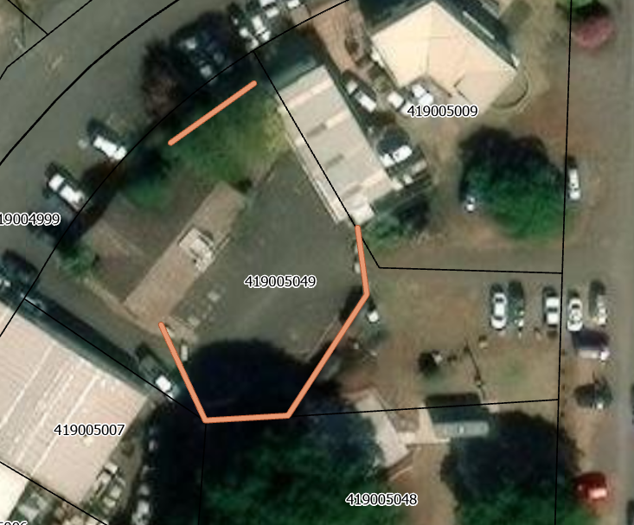

14.0 SITE PHOTOS

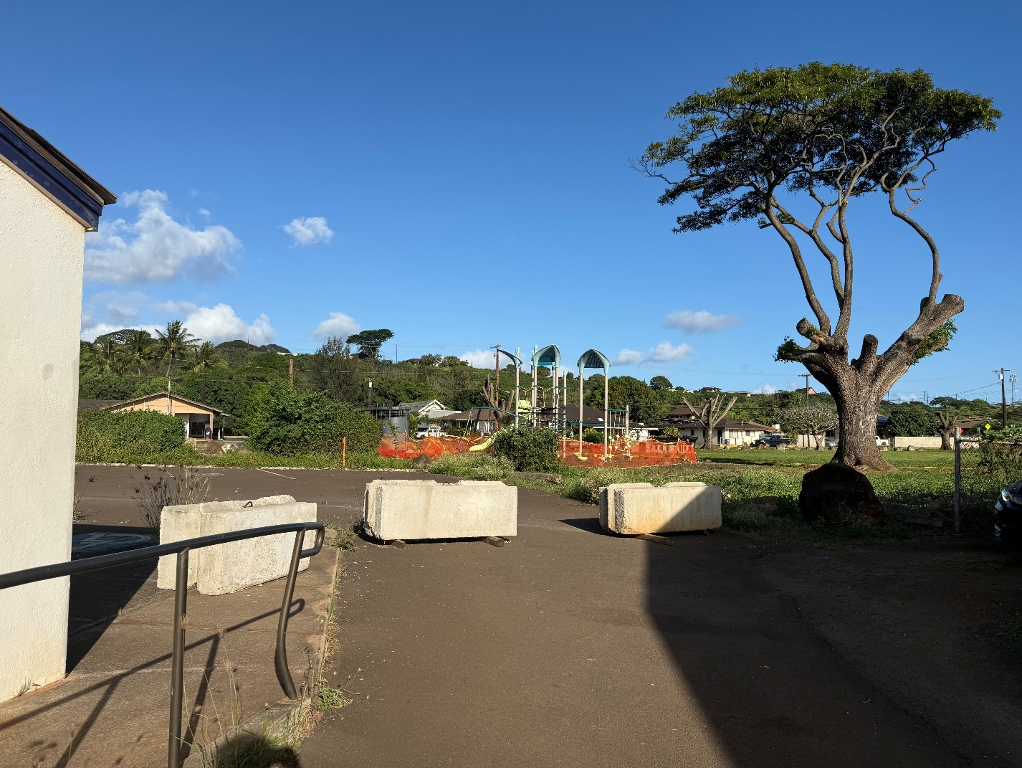
Driveway access. Southwest corner of building to property line and continue east along the boundary
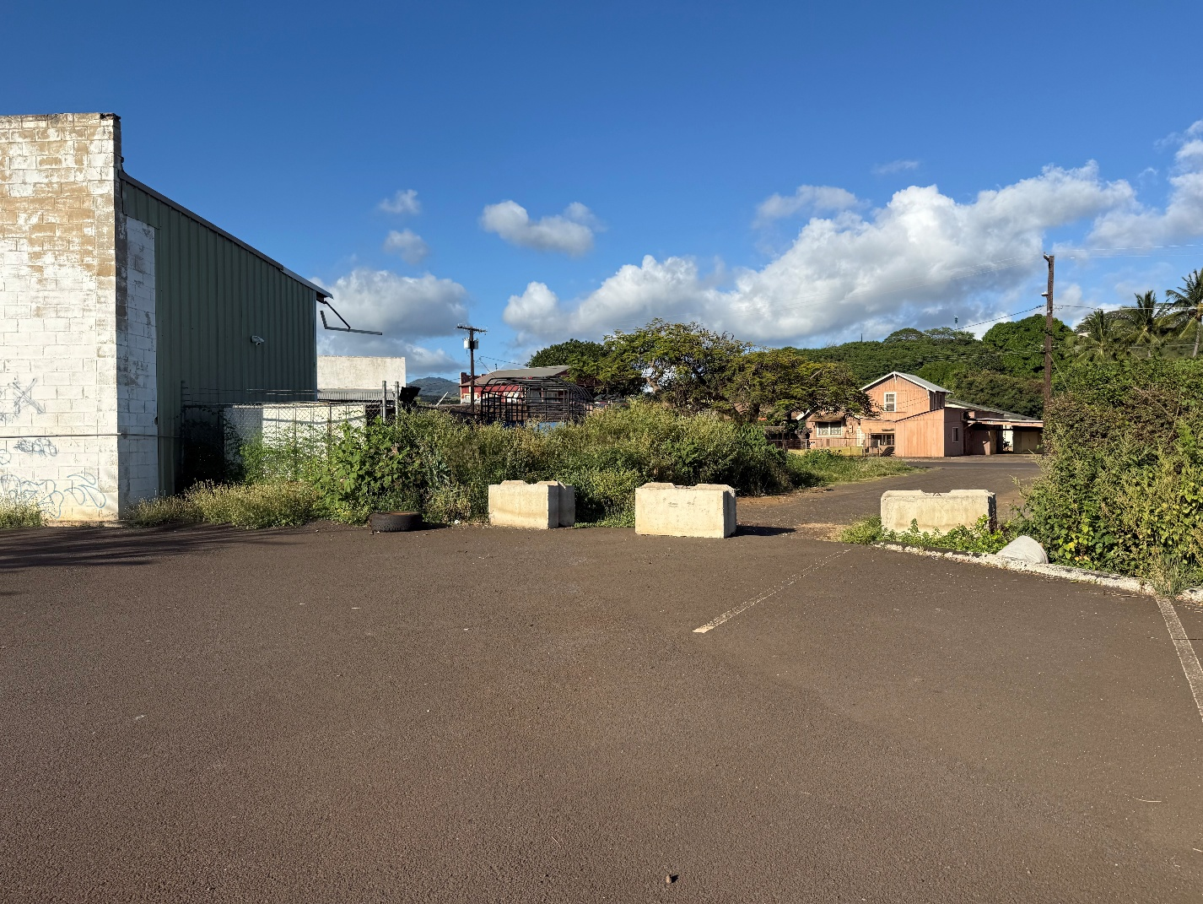
Eastern corner and section connecting to neighboring property fenceline.

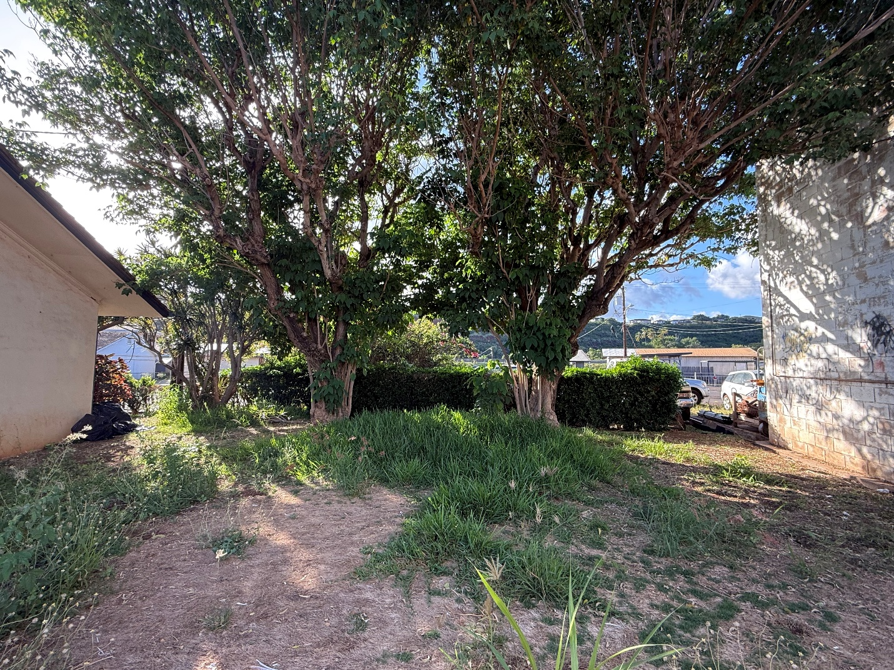
Separate section along the most northern section of the property spanning one building to the next.

